- Create a Simple Pod Using YAML Task: Write a YAML file to create a Pod named firstpod with an nginx container. Verify the Pod creation using kubectl get pods and check the logs of the container using kubectl logs firstpod.
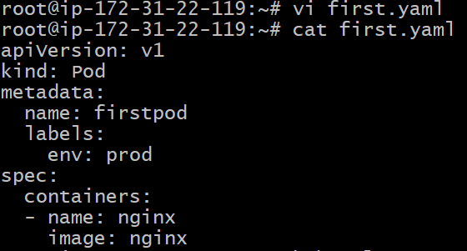
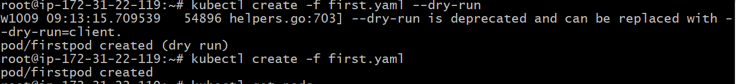
Got an error status is stuck then checked the logs related to network
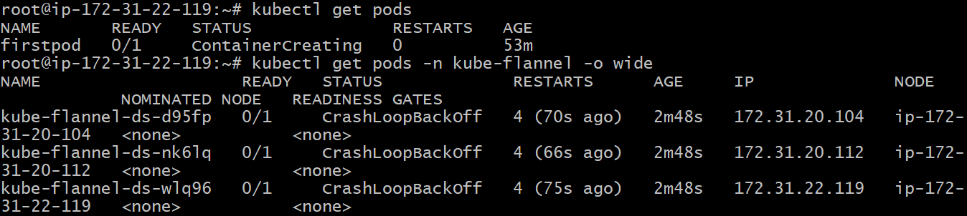
Applied the command to solve the error
kubectl logs -n kube-flannel kube-flannel-ds-wlq96 | tail -n 30
That log will show exactly why all Flannel pods are crashing — common causes include:
- Missing or wrong network interface (needs --iface=eth0)
- Old or incompatible CNI configuration
- Flannel DaemonSet can’t connect to Kubernetes API
Then the status change to running state
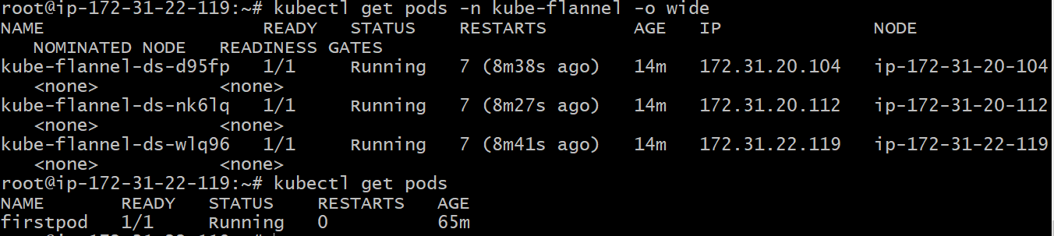
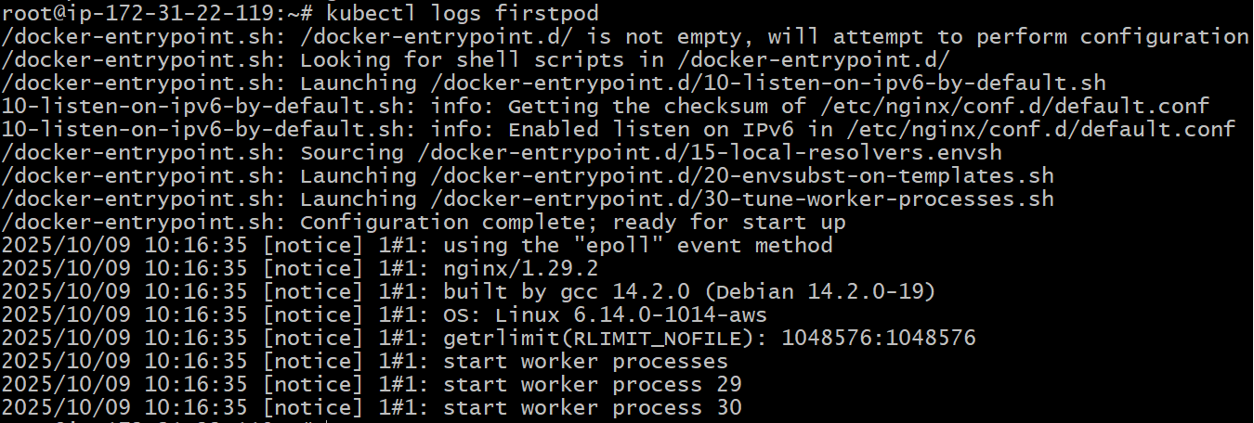
- Set Environment Variables in a Pod Task: Modify the YAML file to include environment variables myname: sabair and City: Hyderabad. Deploy the Pod and use kubectl exec <pod_name> -- env to check if the environment variables are set properly.
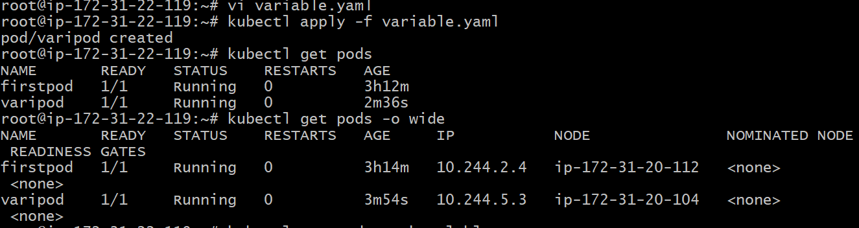
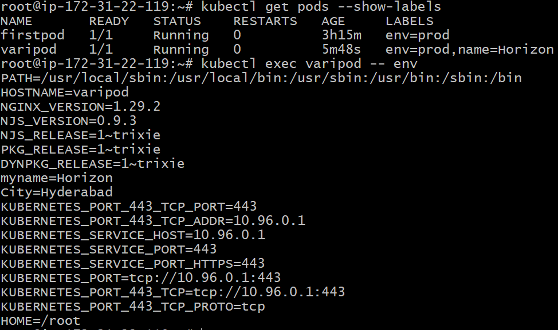
- Deploy a Pod with Commands (Args) in YAML Task: Modify the YAML file to add args that instruct the container to sleep for 50 seconds. Deploy the Pod and use kubectl describe pod to verify the args are correctly passed to the container.

Step 1 — Create the Pod YAML
Here’s a clean example that runs an nginx container but instructs it to sleep for 50 seconds using args.
Save this as pod-with-args.yaml
apiVersion: v1
kind: Pod
metadata:
name: varipod
labels:
env: prod
name: Horizon
spec:
containers:
- name: nginx
image: nginx
args: ["sleep", "50"] # ✅ correctly placed here
env:
- name: myname
value: Horizon
- name: City
value: Hyderabad
Step 2 — Apply the YAML
kubectl apply -f pod-with-args.yaml
Expected output:
pod/args-pod created
Step 3 — Verify Pod status
kubectl get pods
You should see:
NAME READY STATUS RESTARTS AGE
args-pod 0/1 Completed 0 52s
(The pod will run for 50 seconds, then exit.)
Step 4 — Verify args passed to container
Run:
kubectl describe pod args-pod
Scroll to the section under Containers → Command and Args, you should see:
Command:
sleep
Args:
50
That confirms the args were passed successfully to the container.
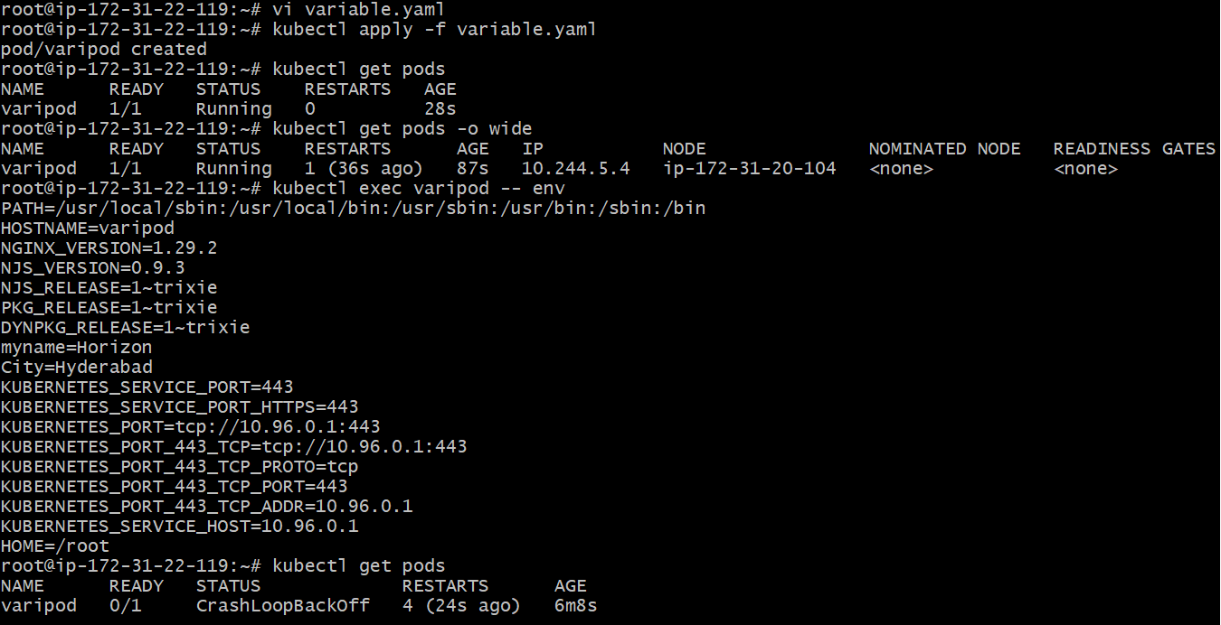
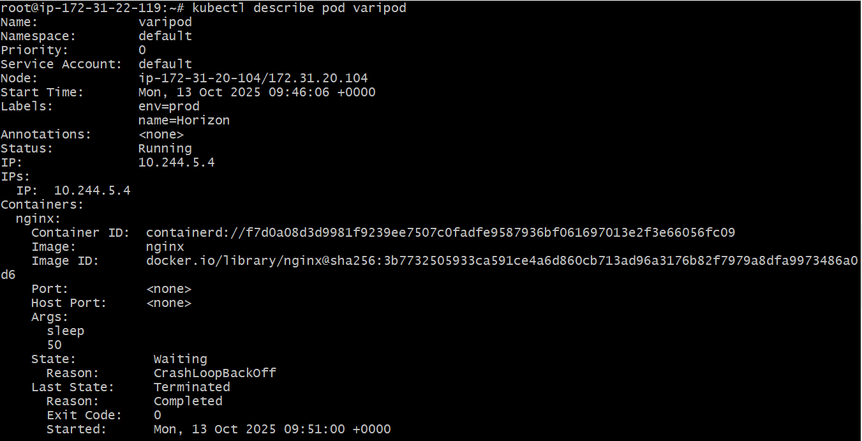
- Create a Pod with Two Containers Task: Create a YAML file to define a Pod with two nginx containers inside. Use kubectl exec to access both containers and verify that both containers can communicate through the same network (e.g., using telnet between them).

Step 1 — Create the YAML
Save this as two-containers-pod.yaml:
apiVersion: v1
kind: Pod
metadata:
name: containerspod
labels:
env: prod
name: Horizon
spec:
containers:
- name: firstcontainer
image: nginx
ports:
- containerPort: 8080

- name: secondcontainer
image: nginx
ports:
- containerPort: 80
args: ["sleep", "3600"] # ✅ correctly placed
env:
- name: myname
value: Horizon
- name: City
value: Hyderabad

🔍 Explanation:
- Both containers (firstcontainer and secondcontainer) run inside the same Pod.
- They share:
  - The same network namespace (so both can reach localhost).
  - The same storage volumes (if defined).
- Ports are just logical — both can access each other via localhost:<port>.

Step 2 — Apply the Pod
kubectl apply -f two-containers-pod.yaml
Check status:
kubectl get pods
Expected output:
NAME READY STATUS RESTARTS AGE
two-nginx-pod 2/2 Running 0 20s

Step 3 — Access Containers
List containers inside the Pod:
kubectl get pod two-nginx-pod -o jsonpath='{.spec.containers[*].name}'
Output:
nginx1 nginx2
Access the first container:
kubectl exec -it two-nginx-pod -c nginx1 -- bash
(If bash isn’t available, use sh.)
Inside the container, install telnet or curl (optional):
apt update && apt install -y curl
Now test connection to the second container:
curl localhost:8080
You should see the nginx default HTML page — proving both containers share the same network.

Step 4 — Test from the other side (optional)
Exit and enter the second container:
kubectl exec -it two-nginx-pod -c nginx2 -- sh
Inside:
apt update && apt install -y curl
curl localhost:80
You’ll again see the default nginx page — confirming internal communication works perfectly.

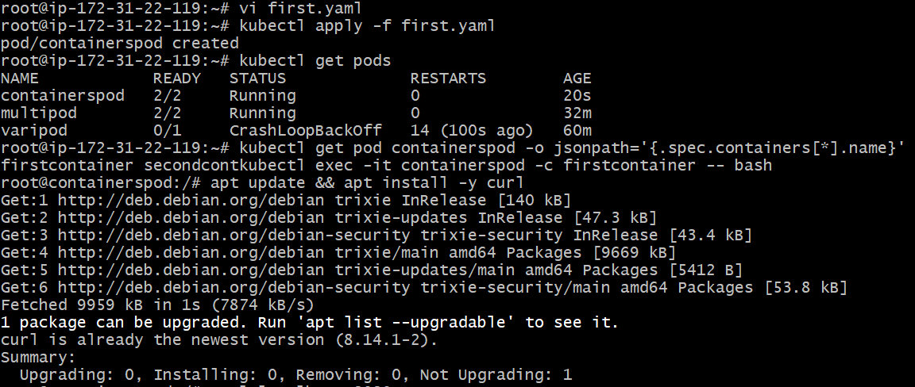
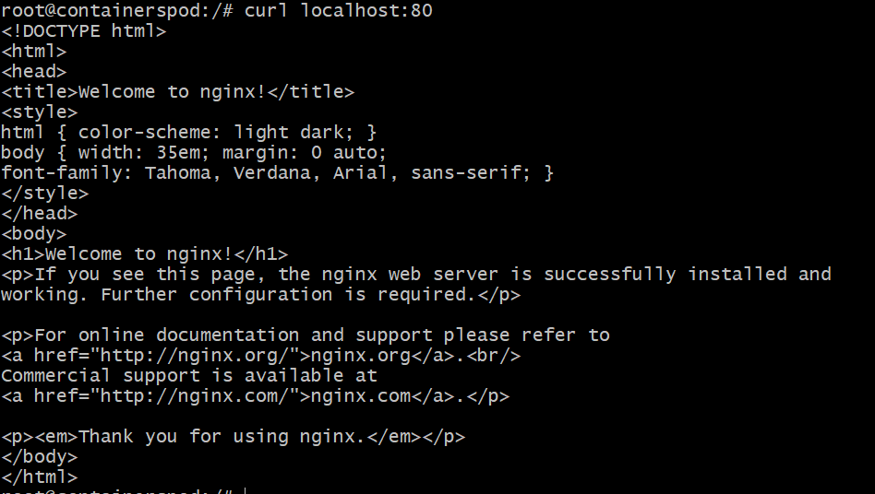
- Set Up an Init Container in a Pod Task: Modify the YAML to include an init container that sleeps for 30 seconds before the main containers start. Verify the init container's execution using kubectl describe pod and check the logs to confirm its completion.

1. Modify the YAML
Here is an example Pod manifest with an init container that executes sleep 30 before the main container. You can adapt it to your actual image and setup.
apiVersion: v1
kind: Pod
metadata:
name: firstpod
labels:
env: prod
name: sabair
spec:
initContainers:
- name: initcontainer
image: busybox
command:
- sh
- -c
- |
echo "Init container sleeping 30 seconds"
sleep 30
env:
- name: myname
value: sabair
- name: City
value: Hyderabad

containers:
- name: firstcontainer
image: nginx
env:
- name: myname
value: sabair
- name: City
value: Hyderabad
- name: secondcontainer
image: nginx
command: ["sleep", "3600"]

You can of course add other settings (volumes, env vars, resource requests/limits, etc) as needed.

2. Apply the YAML
kubectl apply -f pod-init-sleep.yaml
(where pod-init-sleep.yaml contains the YAML above).

3. Verify the init container execution

a) Check Pod status
kubectl get pods firtspod
You might see something like:
NAME READY STATUS RESTARTS AGE
example-init-sleep 0/1 Init:0/1 0 5s
The status Init:0/1 means 0 of the 1 init containers have completed yet. Kubernetes
Eventually, you should see 1/1 (or more, depending on how many containers) and the Pod becomes Running.

b) Describe the Pod
kubectl describe pod firstpod
In the output you’ll find a section like:
Init Containers:
wait-30-seconds:
Container ID: docker://...
Image: busybox
Image ID: docker-pullable://busybox@...
Port: <none>
Host Port: <none>
State: Terminated
Reason: Completed
Exit Code: 0
Started: ...
Finished: ...
Containers:
main-app:
...
Here State: Terminated with Reason: Completed and Exit Code: 0 confirms the init container ran and finished successfully. Kubernetes+1
You’ll also see the overall Pod condition like Initialized = True.
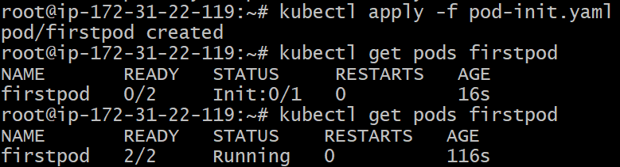
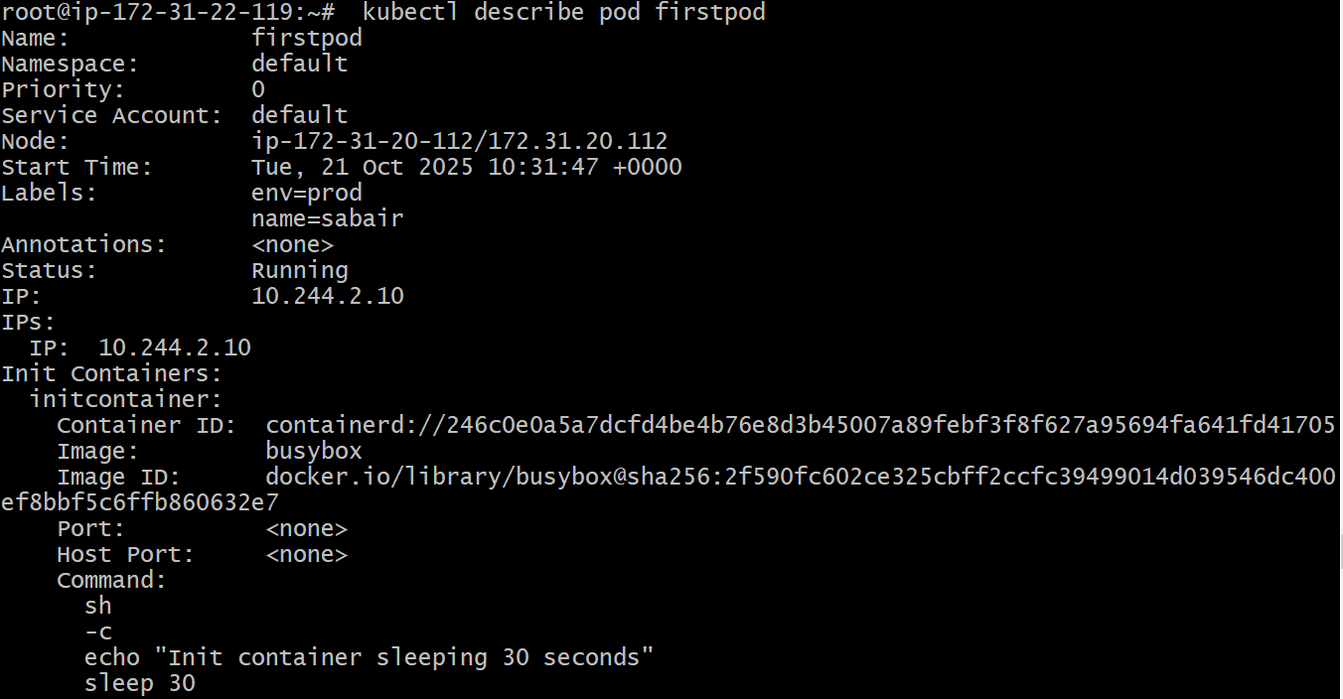
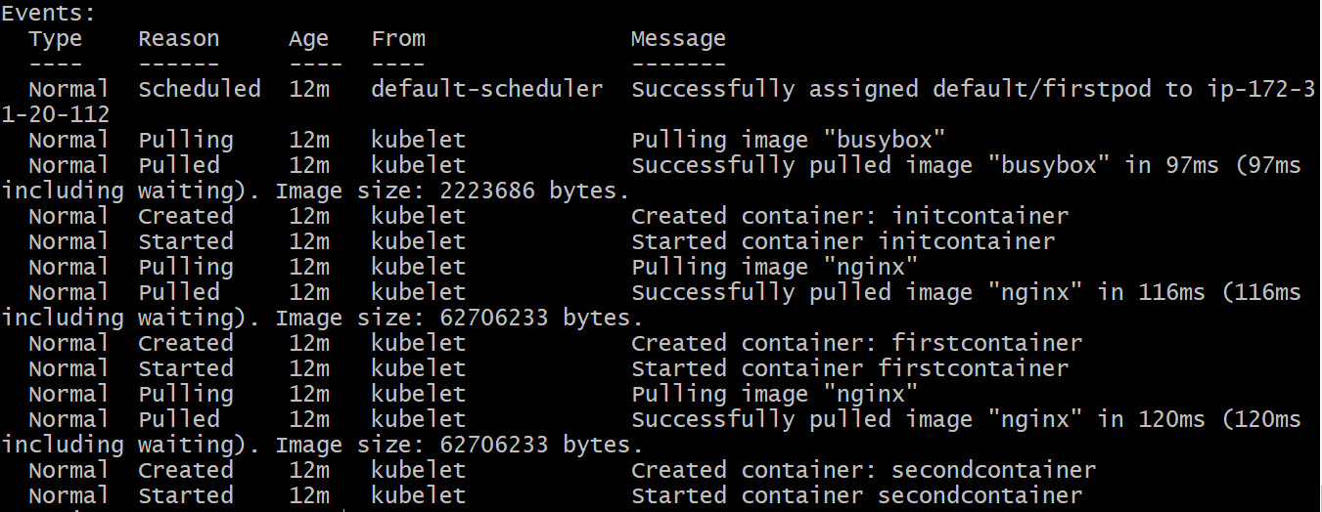
- Run a Dry Run Command to Generate YAML Task: Use the kubectl run nginx --image=nginx --dry-run=client -o yaml command to generate a Pod YAML definition. Modify the generated YAML to suit specific requirements (e.g., labels or environment variables) and deploy it.

1. Generate the Pod YAML using kubectl run with --dry-run
Run the following command to generate a Pod YAML definition for an NGINX container:
kubectl run nginx --image=nginx --dry-run=client -o yaml > nginx-pod.yaml
This command performs a client-side dry run, generating the YAML output without creating any resources in the cluster. The -o yaml option specifies the output format as YAML, and > nginx-pod.yaml redirects the output to a file named nginx-pod.yaml Medium.

2. Modify the Generated YAML to Include Labels and Environment Variables
Open the nginx-pod.yaml file in a text editor and make the following modifications:
apiVersion: v1
kind: Pod
metadata:
name: nginx
labels:
app: web
env: prod
spec:
containers:
- name: nginx
image: nginx
env:
- name: MYNAME
value: sabair
- name: CITY
value: Hyderabad
In this modified YAML:
- Labels app: web and env: prod are added under metadata to categorize the Pod.
- Environment variables MYNAME and CITY are set under the nginx container to pass configuration values Kubernetes.

3. Deploy the Modified YAML to the Cluster
Apply the modified YAML file to create the Pod in your Kubernetes cluster:
kubectl apply -f nginx-pod.yaml
This command creates the Pod as defined in the nginx-pod.yaml file.

4. Verify the Pod's Creation and Configuration
After deployment, verify that the Pod is running and configured correctly:
- Check the Pod's status:
- kubectl get pods nginx
Ensure the Pod is in the Running state.
- Describe the Pod to view detailed information:
- kubectl describe pod nginx
This command provides detailed information about the Pod, including its labels and environment variables.
- Check the environment variables inside the container:
- kubectl exec nginx -- printenv MYNAME CITY
This command should output:
sabair
Hyderabad
Confirming that the environment variables are set correctly.

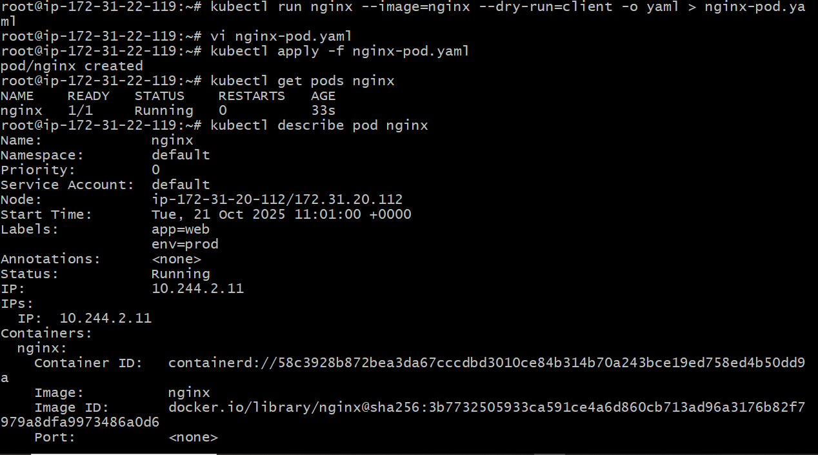
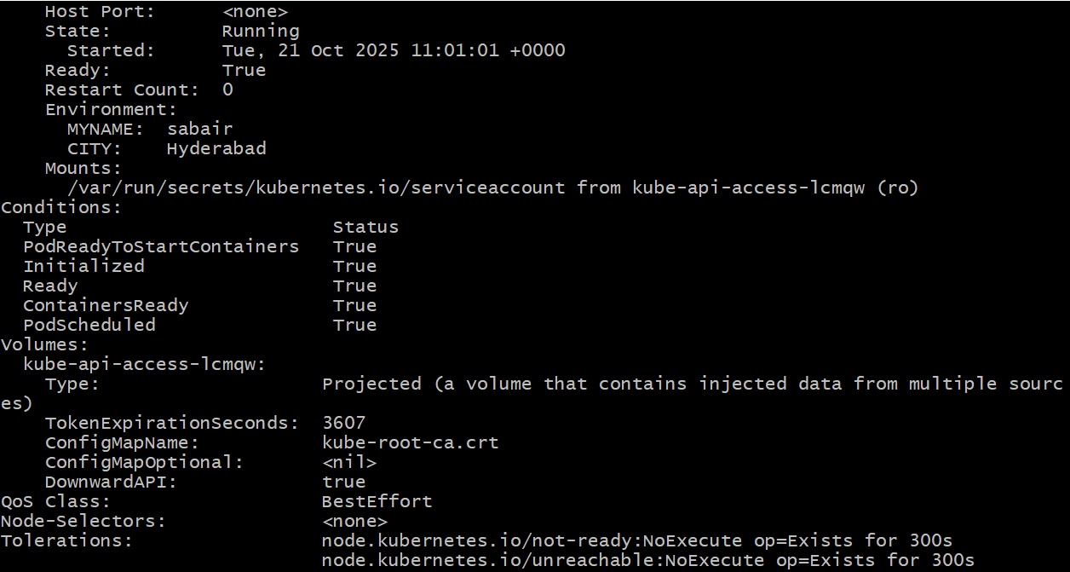
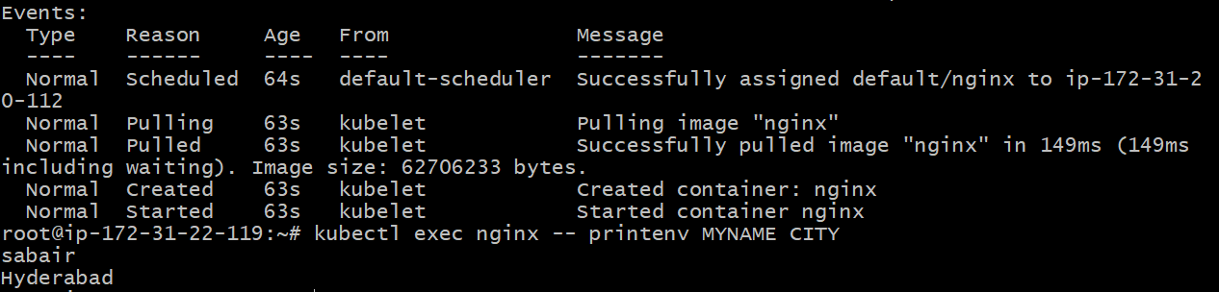
- Use kubectl apply vs kubectl create Task: Create a YAML file to define a Pod. First, deploy it using kubectl create -f <file_name>.yml and then modify the YAML (e.g., change the image version). Use kubectl apply to redeploy and verify the difference between both commands.
- Create a YAML file for a Pod
Let’s make a file called pod-create.yaml:
apiVersion: v1
kind: Pod
metadata:
name: demo-pod
labels:
app: demo
spec:
containers:
- name: nginx
image: nginx:1.19 # initial version
env:
- name: MYNAME
value: sabair
- name: CITY
value: Hyderabad

2. Deploy it using kubectl create
kubectl create -f pod-create.yaml
You should see something like:
pod/demo-pod created
Then verify:
kubectl get pod demo-pod
You’ll see the Pod state (probably Running) once it starts.
3. Modify the YAML

Now edit pod-create.yaml (or save as a new version, e.g. pod-apply.yaml) to change something — for example change the image version to nginx:1.21:
apiVersion: v1
kind: Pod
metadata:
name: demo-pod
labels:
app: demo
spec:
containers:
- name: nginx
image: nginx:1.21 # changed version
env:
- name: MYNAME
value: sabair
- name: CITY
value: Hyderabad
4. Try using kubectl create again with modified YAML
kubectl create -f pod-apply.yaml
Expected behaviour: You’ll get an error like:
Error from server (AlreadyExists): pods "demo-pod" already exists
Because kubectl create won’t update an existing resource — it only creates new ones. That matches what various sources say.
5. Now use kubectl apply to apply the modified YAML
kubectl apply -f pod-apply.yaml
You should see something like:

pod/demo-pod configured
And then Kubernetes will attempt to update the existing Pod’s specification (though note: for Pods many fields are immutable, so in practice this may fail or require recreation). But the key point: apply updates an existing resource.
6. Verify the change
Use kubectl describe pod demo-pod to inspect the Pod metadata/spec and see if the image version changed or some fields updated.
Use kubectl get pod demo-pod -o yaml to view its full YAML and look for annotations like kubectl.kubernetes.io/last-applied-configuration which apply records.
Also check kubectl get pods to see its status (maybe restarted due to image change, etc).
Summary of differences between kubectl create vs kubectl apply
Here are the key differences you’ll observe and that are documented:
kubectl create is imperative: you tell Kubernetes “create this resource now”. If the resource already exists, it will error out.
kubectl apply is declarative: you tell Kubernetes “this is how I want the resource to look”. If it doesn’t exist, it creates it; if it does exist, it will update it to match the manifest.
Resources created by apply get an annotation kubectl.kubernetes.io/last-applied-configuration that helps Kubernetes compute diffs for updates. With just create, that annotation may not exist (you may even get a warning when later using apply on a resource originally created by create).
Because create cannot update an existing resource, you’ll need to delete+recreate or use another command (like replace) for updates. apply handles update scenarios more smoothly.
Best practice: Use apply (and store your YAML in version control) for ongoing configuration management; create can still be used for one-off or experimental resources.
Note / caveats for this task with Pod resource
For your specific task using a Pod (rather than a Deployment), keep in mind:
Changing immutable fields (for example the Pod’s name or the spec’s selector, or certain container fields) may require deleting the Pod and recreating it. So when you apply to modify a Pod’s image, Kubernetes may actually delete and recreate the Pod (or you may see failure if the field is truly immutable).

Because Pods are ephemeral, using apply on Pods is fine for demonstration—but in real production you’ll often use higher-level controllers like Deployment, StatefulSet, etc.
The annotation behaviour still holds (you can check the annotation on the Pod YAML after apply).
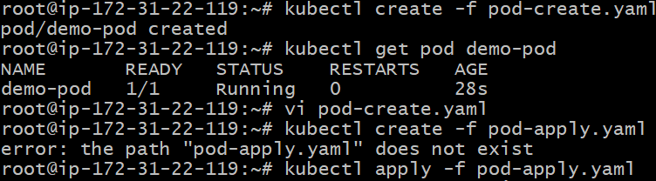
Here modified the yaml file by replace Nginx version 1.90 to 1.21.and see the difference between create and apply.
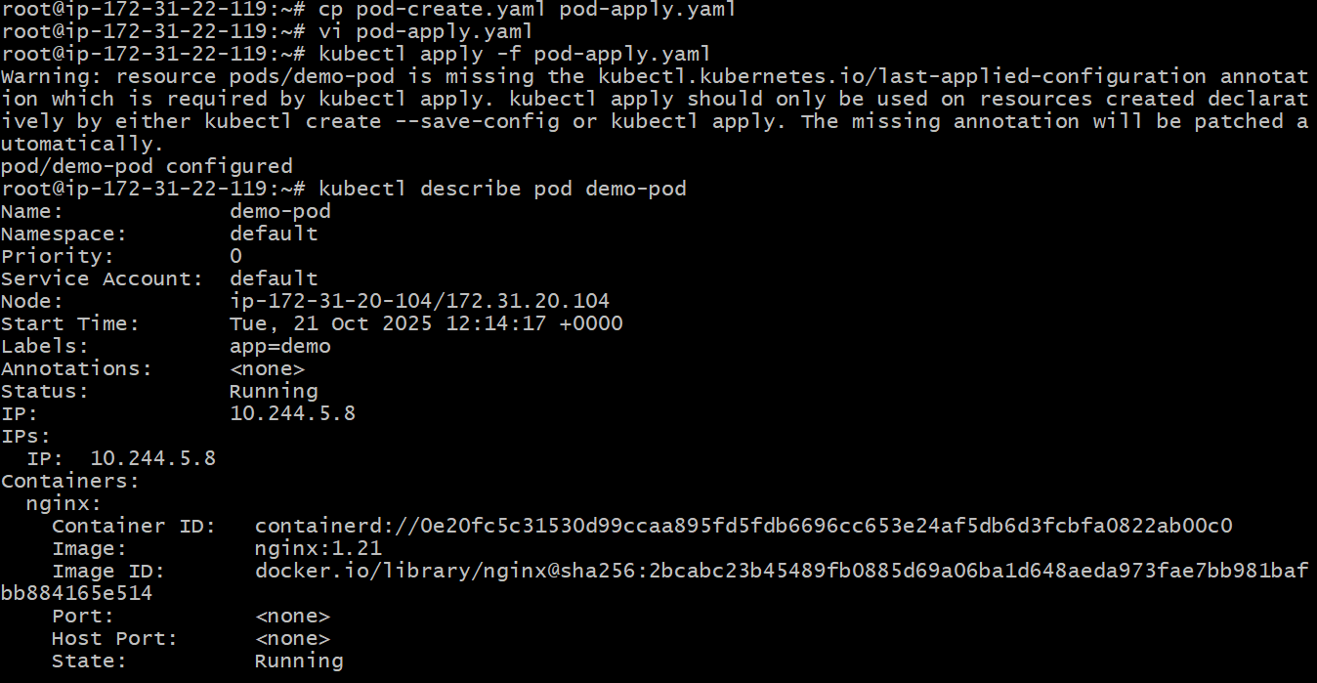
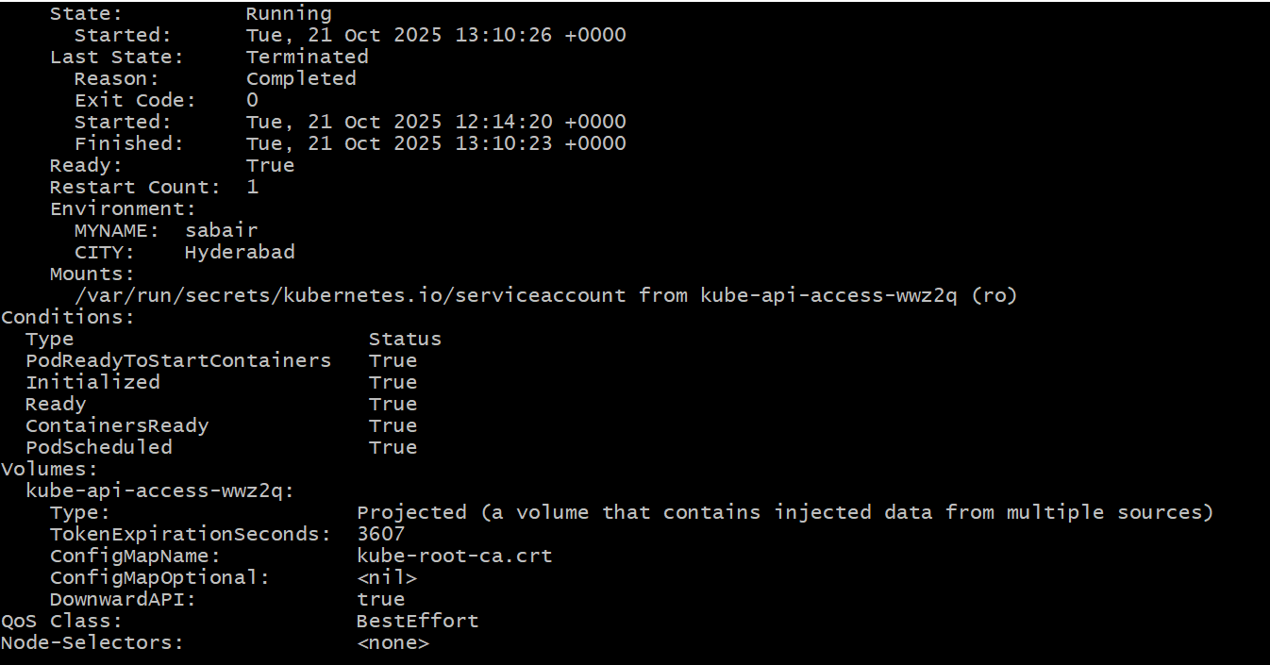
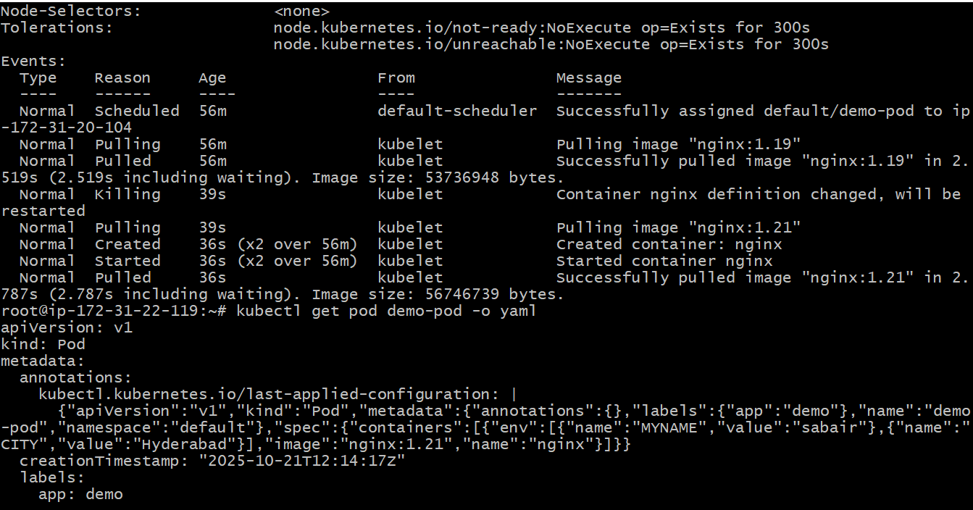
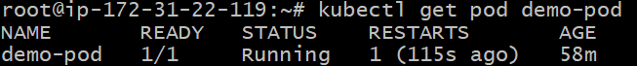
- Edit an Existing Pod Configuration Task: Use kubectl edit pod <pod_name> to modify the running Pod's environment variables or image. After making the changes, verify if they took effect by checking the container logs or environment variables using kubectl exec.
• Export the current Pod spec to a YAML file:
kubectl get pod demo-pod -o yaml > demo-pod-new.yaml
• In demo-pod-new.yaml, modify the image: nginx:1.21 and add or update the env: entries you listed.
• Delete the existing pod:
kubectl delete pod demo-pod
(Ensure that deleting it is acceptable, because this will interrupt whatever workload the Pod is providing.)
• Recreate the Pod using your modified file:
kubectl apply -f demo-pod-new.yaml
• Verify that the new Pod has the correct image and env variables:
kubectl describe pod demo-pod
kubectl exec -it demo-pod -- printenv MYNAME CITY
(Make sure the container name inside the Pod is correct when using kubectl exec.)
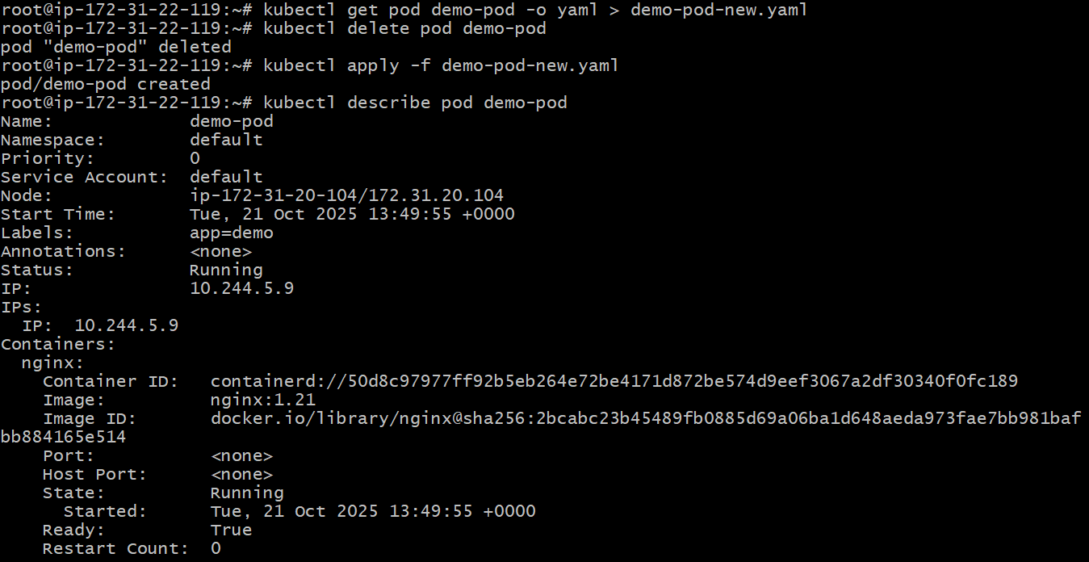
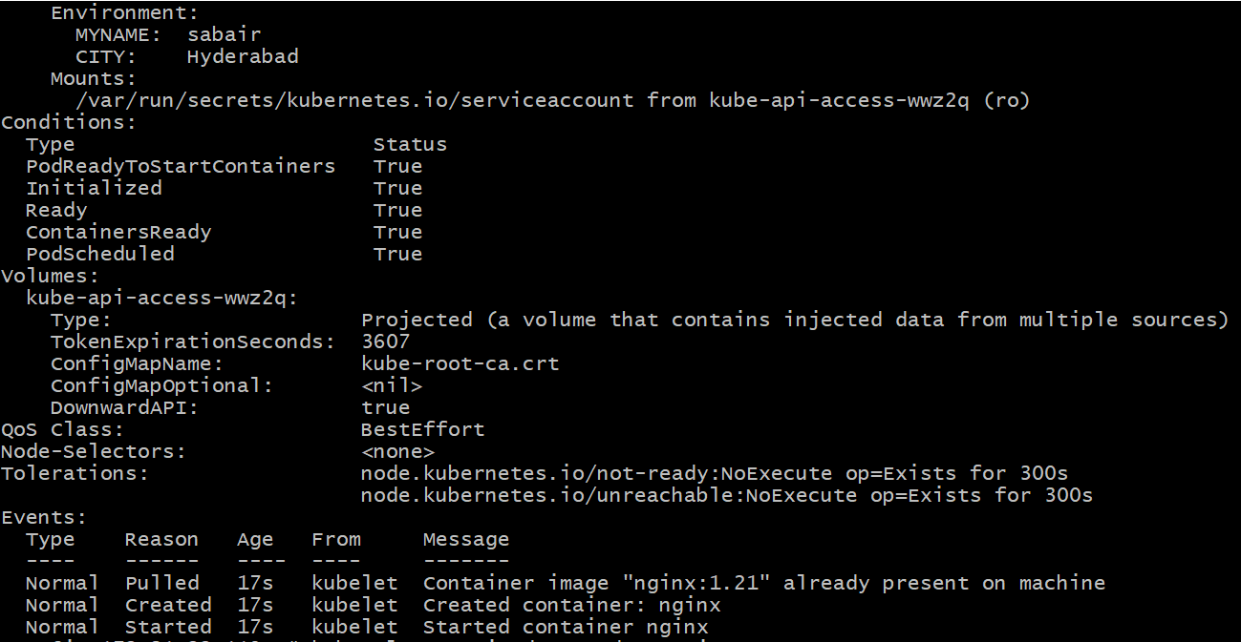
- Expose a Pod Using a Service Task: Create a YAML file to expose your firstpod using a Service (ClusterIP). Ensure that your service is exposing the Pod on port 80 and verify it using kubectl get svc.
firstpod-service.yaml
apiVersion: v1
kind: Service
metadata:
name: firstpod-service
spec:
selector:
app: nginx
ports:
- protocol: TCP
port: 80
targetPort: 80
type: ClusterIP
kubectl apply -f firstpod-service.yaml
kubectl get svc
Your Service is applied, but right now you have no Pods running in the cluster:
🔹 Why the Service shows up but no Pods
● A Service selects Pods based on labels in the selector field:
selector:
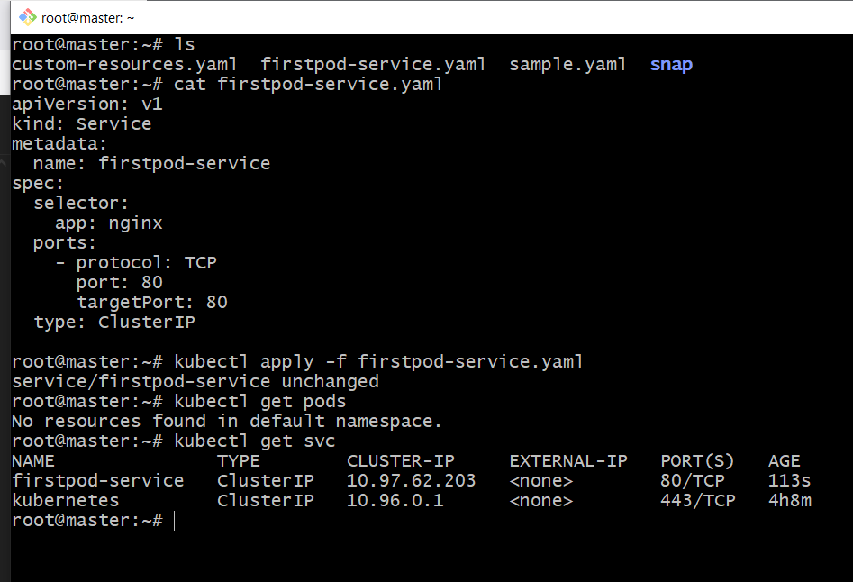
Your Service is applied, but right now you have no Pods running in the cluster:

🔹 Why the Service shows up but no Pods
● A Service selects Pods based on labels in the selector field:
selector:
app: nginx
● But you currently don’t have any Pod with app: nginx label running.
That’s why the Service exists, but it cannot route traffic to anything — it has no endpoints.
🔹 How to fix
- Create a Pod or Deployment that matches the selector. For example:
Pod YAML (firstpod.yaml)
apiVersion: v1
kind: Pod
metadata:
name: firstpod
labels:
app: nginx
spec:
containers:
- name: nginx
image: nginx
ports:
- containerPort: 80

kubectl apply -f firstpod.yaml
kubectl get pods
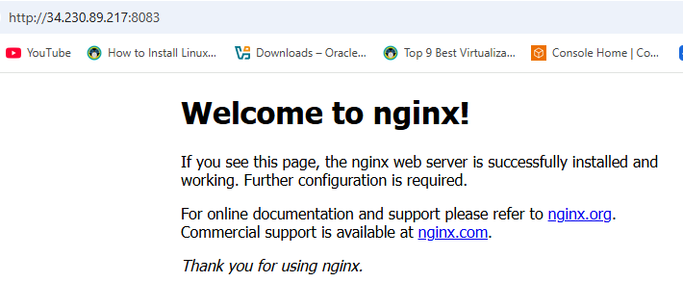
Now your firstpod-service will actually route traffic to the running Pod.
- Pod with Resource Limits and Requests Task: Add resource requests and limits to the containers in your YAML file. Specify CPU and memory requests/limits for both containers and deploy the Pod. Use kubectl describe pod to verify if the resource configurations are correctly applied.
pod-resource-limits.yaml
apiVersion: v1
kind: Pod
metadata:
name: resource-pod
spec:
containers:
- name: nginx
image: nginx
resources:
requests:
memory: "128Mi"
cpu: "250m"
limits:
memory: "256Mi"
cpu: "500m"
kubectl apply -f pod-resource-limits.yaml
kubectl describe pod resource-pod
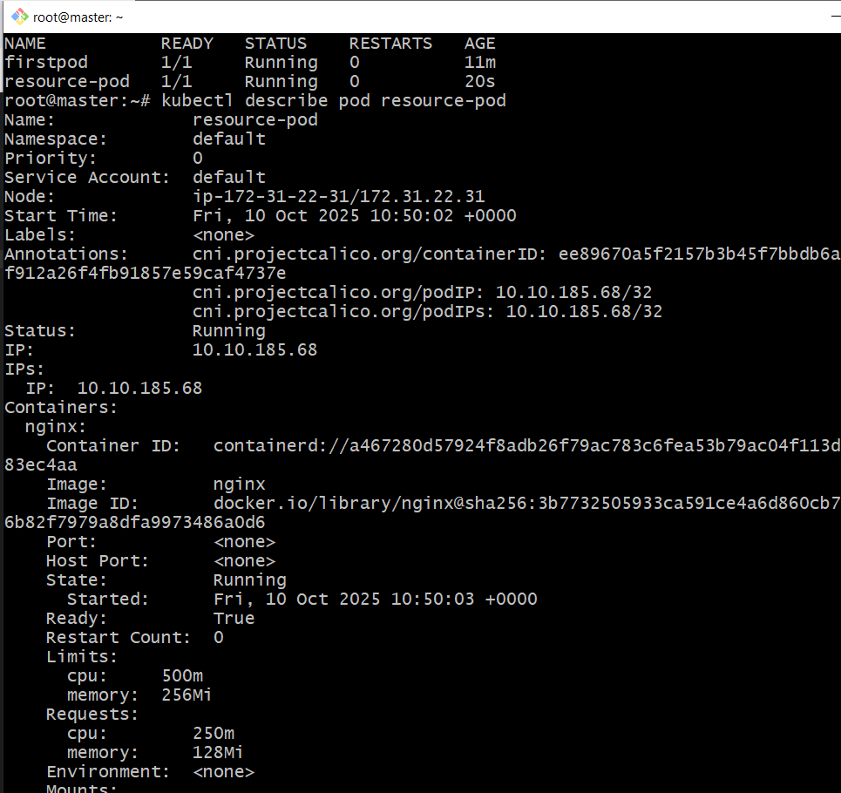
Verify: Under Resources, you should see the configured CPU/Memory values.

